Documentation

Using Microsoft visual studio for the database code and linkage

Downloaded [sqlite](https://www.sqlite.org/download.html) and [openssl](https://www.openssl.org/source/) from the web

Added sqlite files to project

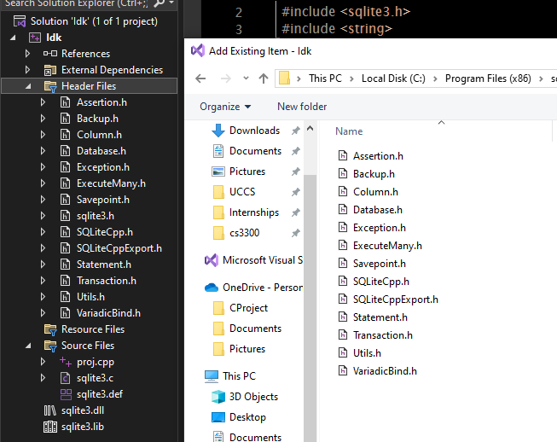

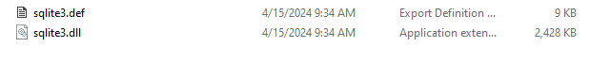

From the properties in the project 🡪 configuration properties 🡪 vc++ directories

Add openssl include directory to the external include directories to link openssl



Added the path to the different libray files that are needed for openssl to run. The library directory and the static library directory





Next in the C/C++ settings in additional include directories added the path to the directory with all the needed header files to be linked for use. Sqlite.h and the include header files



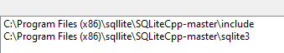

Finally, in the linker settings and the additional library dependencies add the path to the sqlite3.lib file to the directories so that it will link correctly with the dependencies



Created database use program and ran it by itself. Worked correctly but now have to integrate the database code into the main password manager code.

First had to copy files from Stephanie’s GitHub then re do all the steps above to get the sqlite to work properly with the new code

Changed manager.h by adding a sql query to insert username and password into database

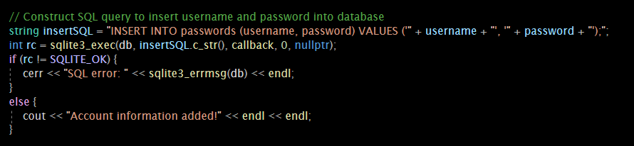

Updated viewpasswords function to pull from that database

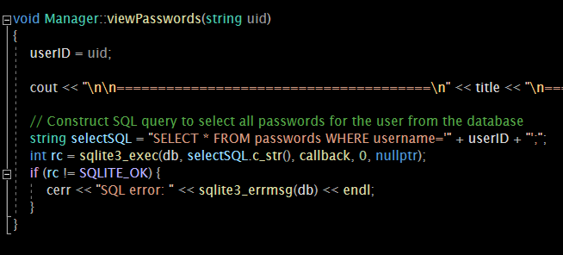

Updated main.cpp to include sqlite3 database and create if not exist and open it if it does. It then creates the database table

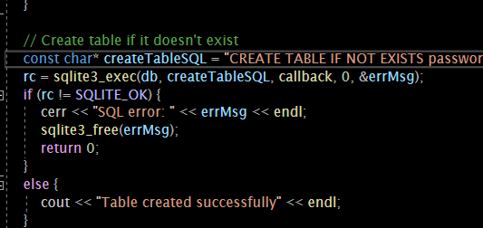

When the username and password is entered it then stores it to the database file.  
Working on openssl encryption of the password and username before storage.